Please feel free to view from different angles via cushions, chairs, floor.
Move as you wish around the dimly lit space.
OK to come and go
i.e. Gus’ café and market across the street + open art studios next door.
7pm Discussion with artists and writers, moderated by Hope Mohr; 8pm Closing Bridge Project Event
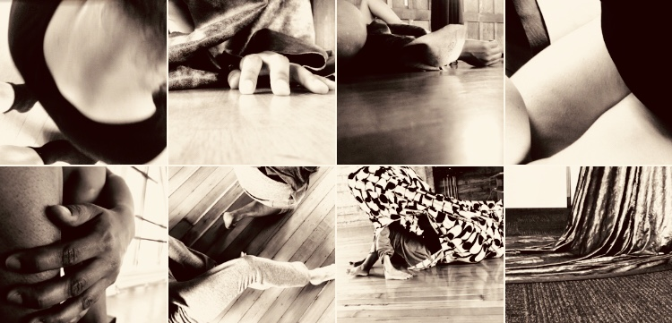
A.U.L.E. - an un-named lived experience
& being with another seems to go by very fast. so much information. so much to tend to think about and the how of time talking thru how we resist, breakaway then give away. sensing bringing forward slinking back. why and what? stutter gasp. wait. what i wanted to say (because some fumbly dimming) and what that is: to be interested in. drop narrative like how there can be a split in the because. so description does not have a together & becomes again. the title perspectives. thin lines might be imagining the experts - leaning, convening and reverie and skins and what’s missing and all those rising - break - to see the small axis as axes. rushing to get it right. hard corps proposition stained and streaming. herbal opaque judge and unrecognizable currents and cruelty with utopia’s little edges. the separate conversations radiate dark root bodies & an aural portal, a vibe. or two or three or four or five or seven of us with each other’s other/s. all together above and below. all a part of this.

Featuring: Larry Arrington, Xandra Ibarra, Maurya Kerr, Amara T. Smith with Debra Levine, Scot Nakagawa, Patrick Murch, Julie Tolentino
Concept & Installation by Julie Tolentino
with support of 2017-2018 HMD Community Engagement Residency & The Bridge Project: Radical Bodies Series
Many thanks to Marcela Pardo Ariza,
Pigpen/Stosh Fila, Dan N., Jon M.
Dedicated to Natividad Sayo Tolentino

